TRUSTWORTHINIESS * RESPECT * RESPONSIBILITY * FAIRNESS * CARING * CITIZENSHIP

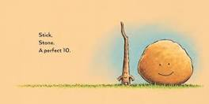

STICK AND STONE
MAKING CONNECTIONS

- Stick and Stone are lonely. How do they become friends? What does Pinecone do to Stone? Have you ever been in a similar situation? Talk about it. How did you handle it?

- People can be alone but not lonely. Talk about what that means.

- Can you think of someone who is alone right now? Think of ways to show people you CARE. Maybe you can call that person or mail them a drawing.

- Why does the author call Stick and Stone a “Perfect 10?” What does that mean? Can anyone be perfect?

- Challenge activities: Read, I Know How You Feel. Complete the puzzler activities in Bookflix!

