TRUSTWORTHINIESS * RESPECT * RESPONSIBILITY * FAIRNESS * CARING * CITIZENSHIP

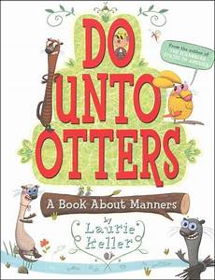
Do Unto Otters
Laurie Keller
MAKING CONNECTIONS
- Do Unto Otters is a book about the golden rule. What is the golden rule? (Treat others the way you want to be treated.)

- Do you remember which one of the six pillars of character talks about the golden rule the most? (Respect)

- Mr. Rabbit gives many examples of how he would like to be treated by the otters. How many examples can you remember? Make a list of the words and practice your kindness skills everyday!

- How does author play with the words in the title? Why does she do this?

- Challenge activities: Read, We are Citizens. Complete the puzzler activities. 