TRUSTWORTHINIESS * RESPECT * RESPONSIBILITY * FAIRNESS * CARING * CITIZENSHIP

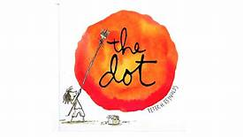
The Dot
Peter H. Reynolds
MAKING CONNECTIONS
- Vashti would not leave her art class. Then, she jabbed the paper with a marker. What feeling words best describe her mood?

- Is it a big deal that Vashti didn’t finish her art? Why or why not?

- Vashti’s teacher frames the dot and hangs it on the wall. It’s only a dot! Why did she do that?

- What does ‘experimenting’ mean? Give examples of how Vashti experiments with dots.

- What did Vashti learn from her teacher? Hint…it has nothing to do with art!!!

- How does Vashti help another student at the end of the story?

- Challenge activities: Read, All the Colors of the Rainbow. Complete the puzzler activities in Bookflix!

