Video Club
October Assignment:
- Make a 60 second (or less) PSA video:
PSA: A Public Service Announcement includes short messages which inform the public or changes public opinion, actions, or feelings.

Select one of the following for your PSA video:
    - Thanksgiving Food Drive
    - Donate Halloween Candy
    - How to be a good Citizen
You may work alone for this project, but we suggest that you work in a group!
Videos are due at our next meeting, November 4th.

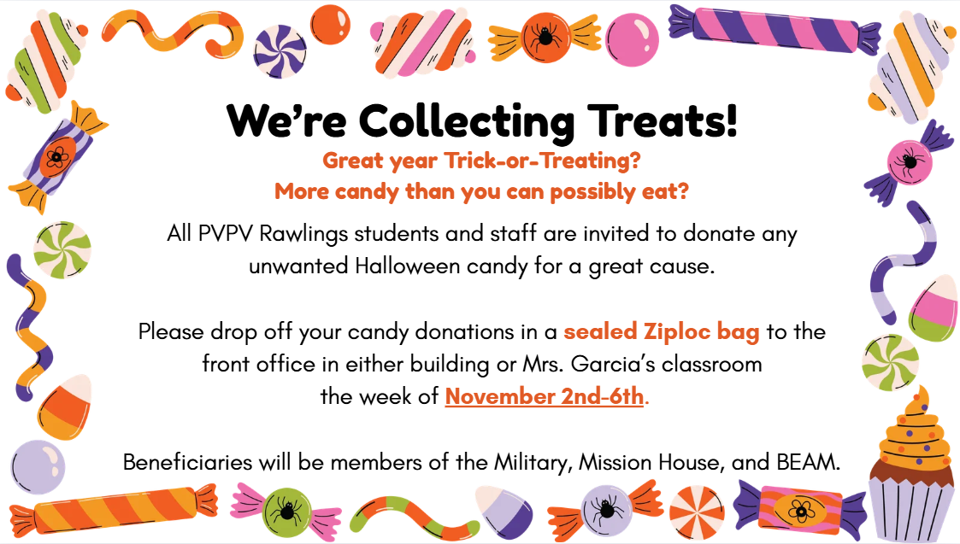

Citizenship:
Being a good citizenship means fulfilling civic and social responsibilities and contributing to the well-being of your home, school, neighborhood, country, and the wider world.
Key beliefs include:
- Contributing to your community and meeting your responsibilities.
- Obeying the law as a way to contribute to society.
- Recognizing you are part of many communities and that positive contributions are required.
- Maintaining an open mind, willingness to reconsider your own views, and respect for others’ arguments.
- Taking responsibility for environmental stewardship

